Report A New Defect In Jira
Step-by-Step to Create a Issues:
In JIRA, a defect (or bug) is reported when an application or system does not behave as expected. To log a new defect, you create an issue under the Bug/Defect issue type. While reporting, you typically provide key details such as:
- Project Name – The project where the defect belongs.
- Issue Type – Select Bug or Defect.
- Summary – A short title describing the defect.
- Description – Detailed steps to reproduce, actual result, expected result, and any relevant information.
- Priority/Severity – To indicate the impact of the defect.
- Environment – Details about browser, OS, version, or test environment.
- Attachments – Screenshots, logs, or videos to help developers understand the issue.
Once submitted, the defect is tracked through the JIRA workflow (e.g., Open → In Progress → Resolved → Closed) until it is fixed and verified.
Procedure to Create a issues.
1st login into Jira Tool.
2nd Click into a Client, Which You want to create a Bug/issues.

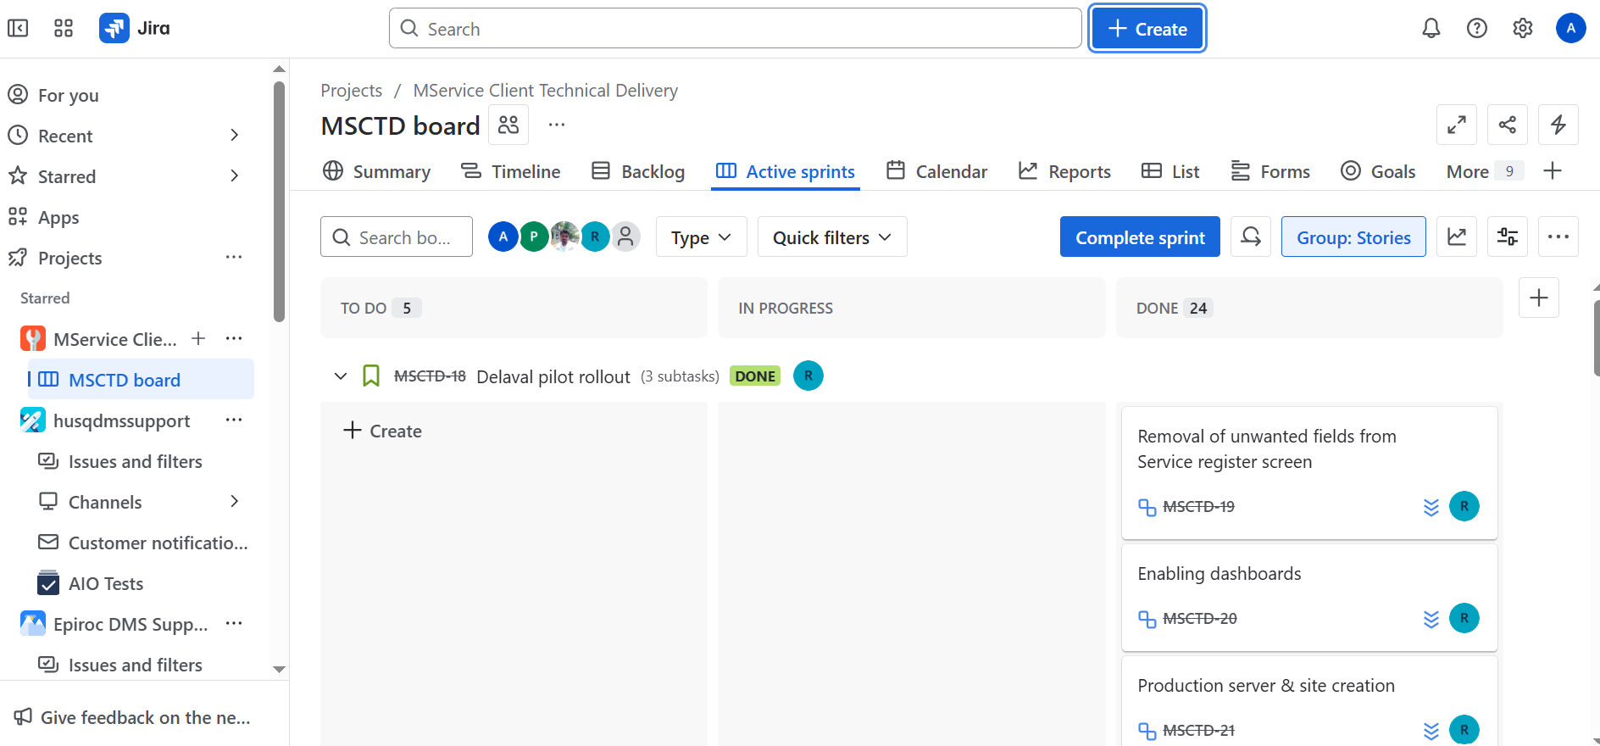

3rd Click into a +Create Issues.
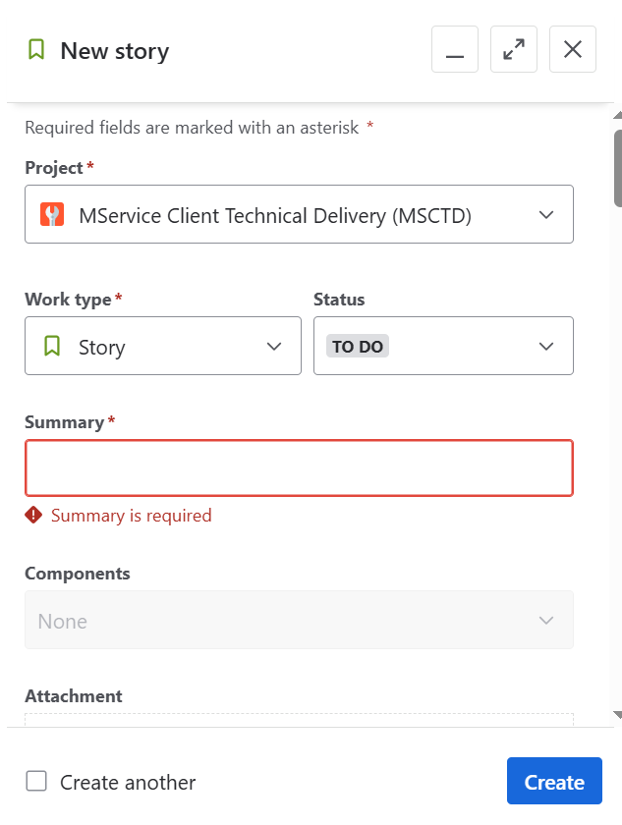
4th The page Should be Open issues Create Page.

5th We need to Select a Project Which We are Working.
6th If you have a multiple project , Click into a Drop Down button and Search for a project.
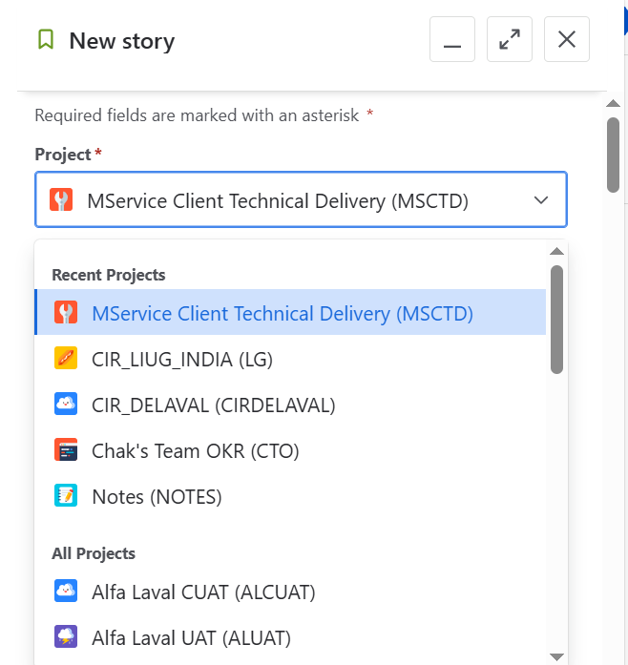

7th Create a Work Type. Which is a correct One.
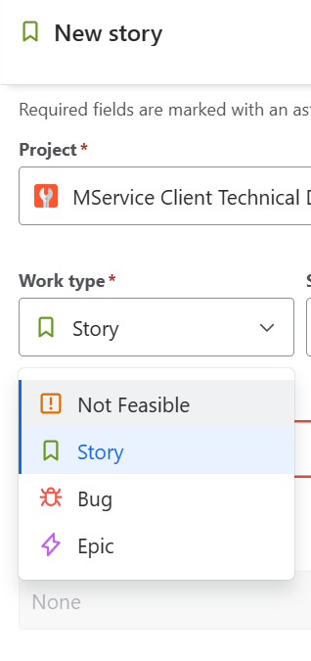
8th Option are Bug, Epic, Story, Not Feasible.

9th Click into a Statues, and Click into a Current Status.
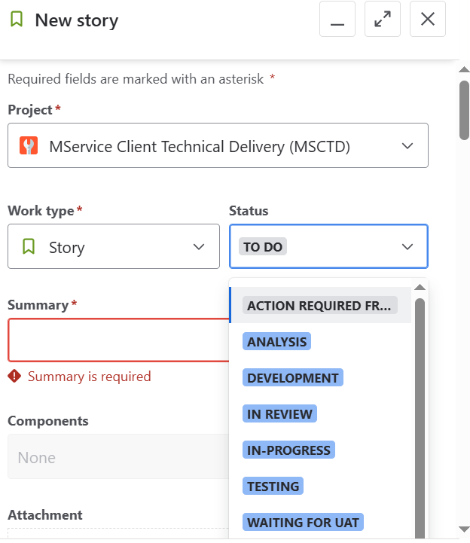

10th Add a Summary, like Minimal No of Description, What a Real Issues
11th About The issues.
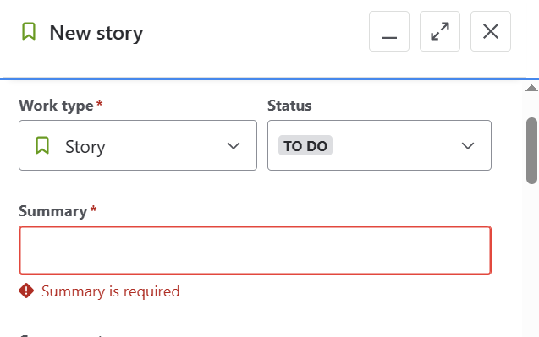

12th If we need to create any component we add in the Component Field.
13th If we need to attachment any Screenshot for a proof we can add it.
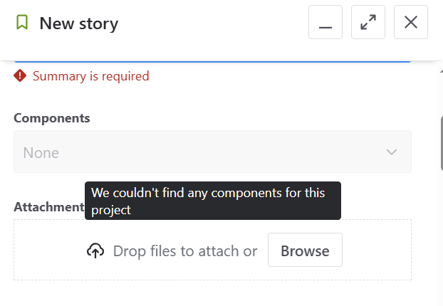

14th We need to Describe a complect issues , clearly in the Description Box.
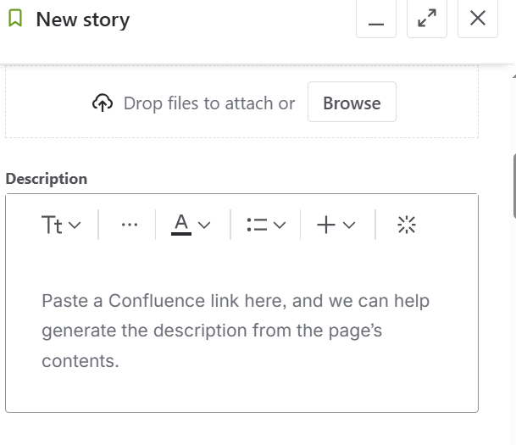
`15th In this box , we mention What is a Actual Result and What is Expected result.

16th fill the Linked work items.
17th Select the option, Which is Related of bug.
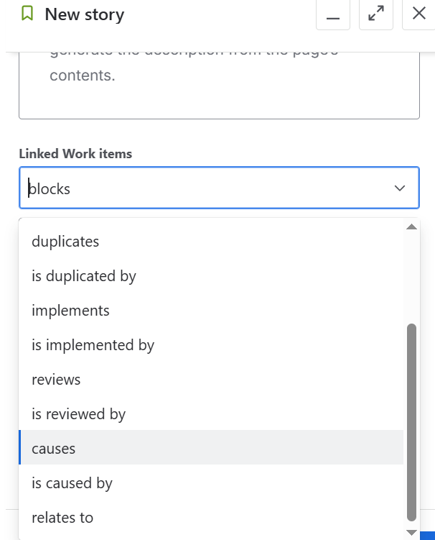
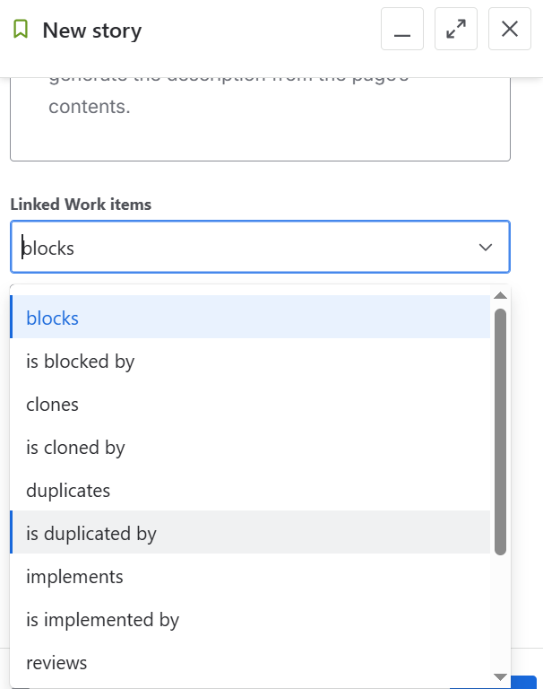

18th Select Work Items.
19th if we need to Check on Versions, we can add the Fix Version.

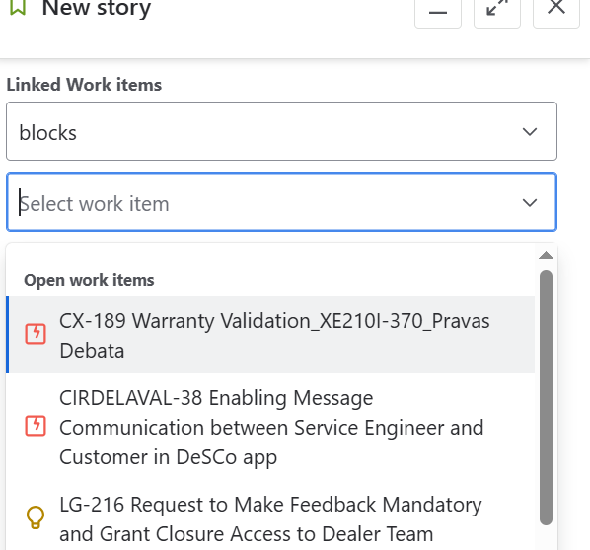

20th We need to Fill the column Of Assigned.to be reviewd.
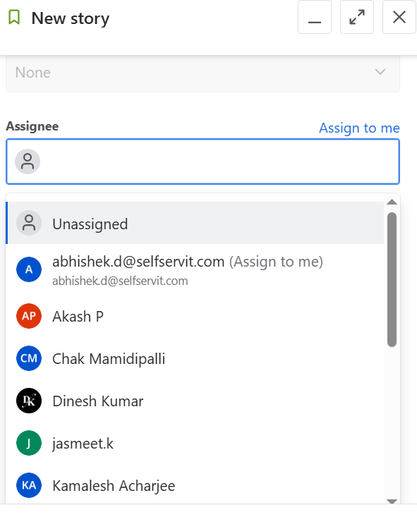

21th We need to mention the Priority. To be Clarify.

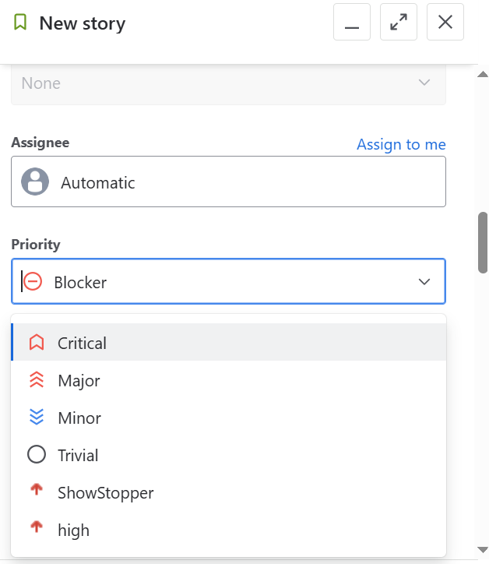

22th Select labels , which is already pined.
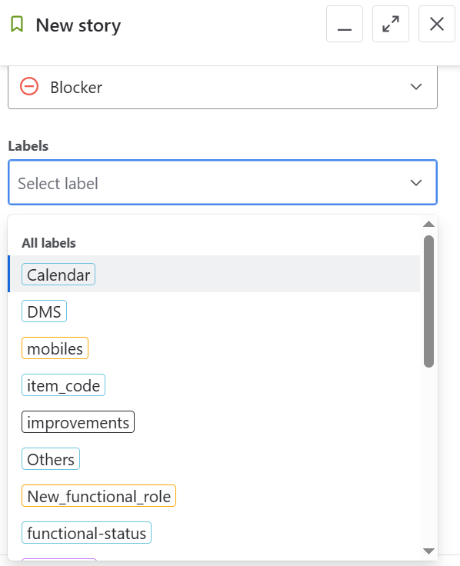

23th if we need select a parent .
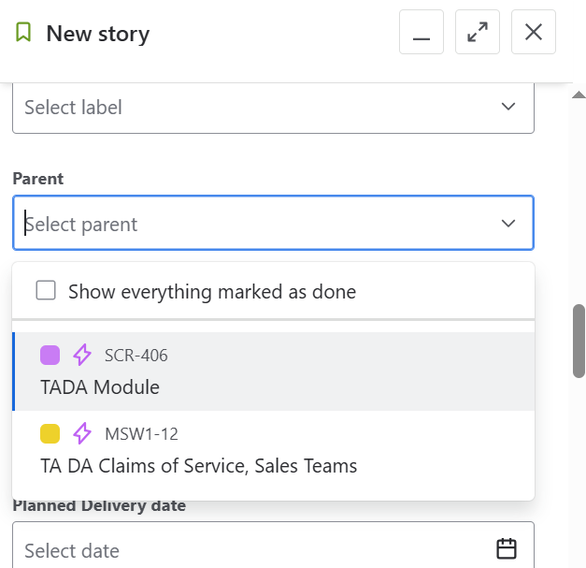

24th Select a Sprint and plan a Sprint.
25th We need to mention a Sprint is mandatory.
26th We need to mention a plane Delivery date.
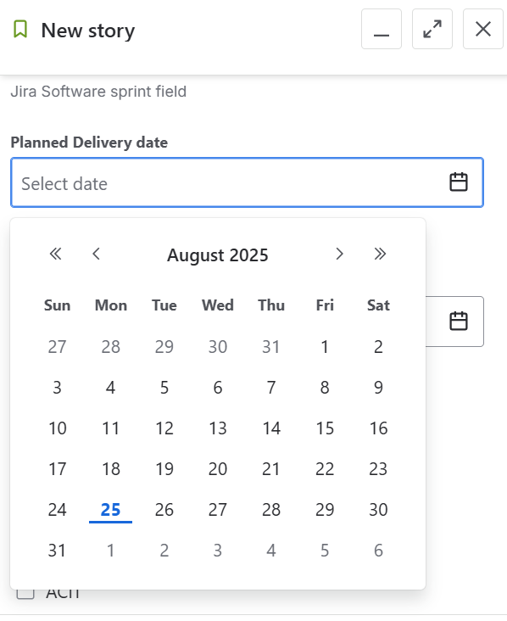

27th We need too submit actual Delivery date.
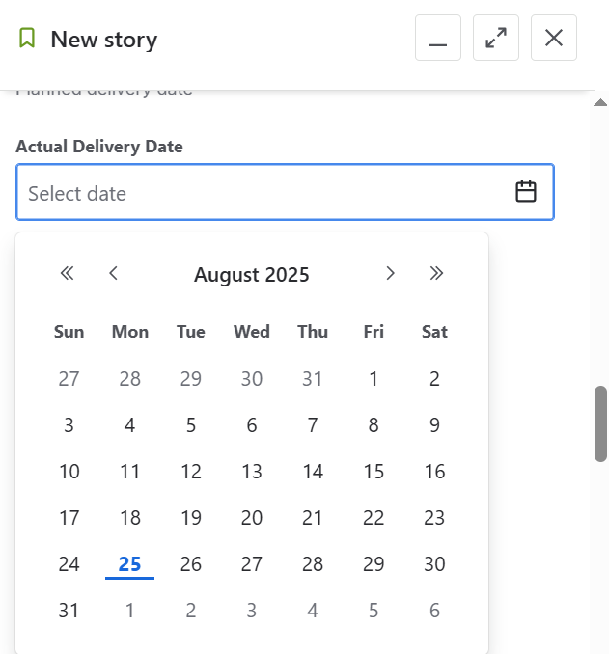

28th we need to Fill the Client Id. Which we need to select.
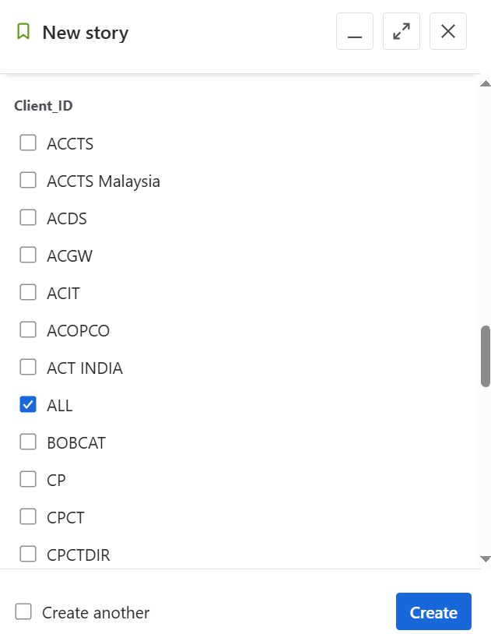

29th we need to select a ratio button of parent MSCTD.
30th we need to Fil the form Of Sign up
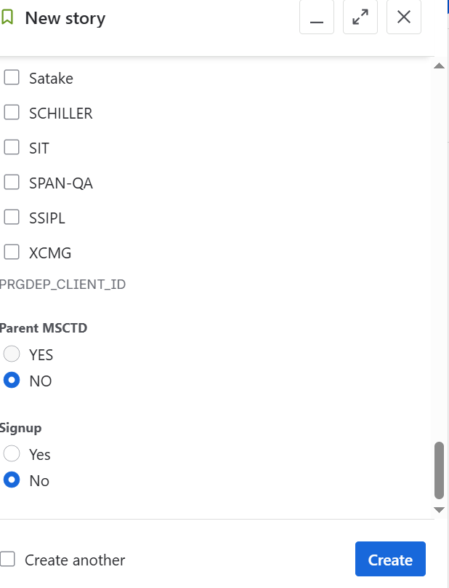

31st And Click into Create.

